BARCLAYS NEWBOURNE PARISH COUNCIL



SWIFTBIC BUKBCB22

IBAN GB49 BUKB 2098 0740 6623 99

Issued on 06 June 2022

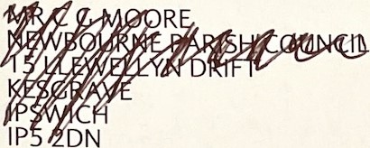

|  |  |
| --- | --- |
| Your Community Account | At a glance |

05 May - 01 lun 2022

Start balance

5 May Start Balance 18,857.94 Money out E578.91

Total Payments/Receipts 578.91 0.00

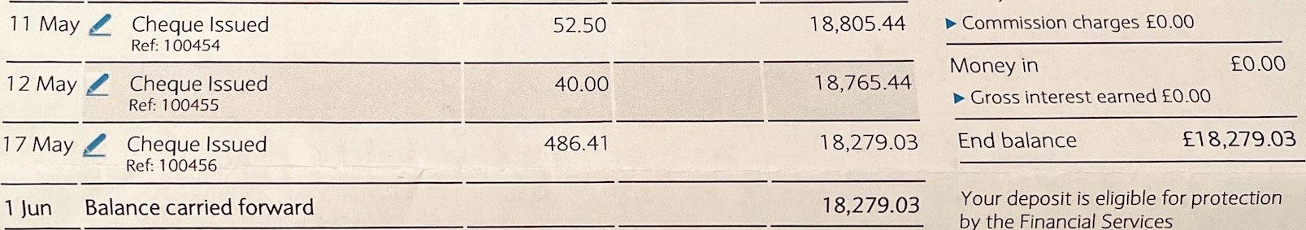

Compensation

Scheme.

Anything wrong? If you notice any incorrect or unusual transactions, see the next page for how to get in touch with us.



