Newbourne Parish Council
Minutes of the Parish Council Meeting held on Tuesday 6th June 2022
In attendance: Councillors Scott, Frost, Pollard, Wicks, Grainger, Gammons, Hadley and Gareth-Cox. ESC Cllr Richardson
Members of the public: 4
Meeting opened 20:00
Parish Issues – An opportunity for parishioners to bring matters to the attention of the Parish Council and for parishioners to seek guidance from the Council
Public Time: Internet In the village hall was discussed in public time. It was discussed that internet in the village hall would be beneficial in the future
- To be able to view the CCTV on the village hall from a remote location.
- Would mean that members of the parish council unable to attend in person could therefore log in via zoom or teams.
- Wi-Fi would be a good when people are renting the village hall for children’s disco’s etc
Pat Frost and Sue Pollard will investigate internet options and will be added as an agenda point for next meeting.
20:15
- To RECEIVE apologies for absence: Cllr Lusher and ESC Kerry.
- To RECEIVE reports from SCC Cllr Patti Mulcahy, ESC Cllrs Richard Kerry and Mick Richardson, and Suffolk Police.
Ward Councillors Report
Mick & Richard
michael.richardson@eastsuffolk.gov.uk
Telephone No:
01502 523521
Work Telephone No:
07810 816018

Email:
richard.kerry@eastsuffolk.gov.uk
Mobile Telephone No:
07903 301075

This Local Authority Trading Company (LATCo) will operate as an ‘arms-length’ commercial business, separate to the Council, following the conclusion of the contract East Suffolk Council holds with Norse for the provision of operational services in July 2023.

Supporting customers to get online
Our Customer Services Team now have fully trained ‘Digital Champions’, who are available to help customers use our online services at the Marina Centre in Lowestoft and at desks within local libraries, by appointment.

Most East Suffolk residents now use our online services to report issues, make payments and find out information, however some people find it more challenging to use these services.
Our Digital Champions are available for anyone who needs support to get online, not only to learn how to use our online services but to also feel more comfortable with online shopping, banking, using email and connecting with people.
Appointments are available at the Marina Centre and at desks within libraries across the district. To make an appointment with a Digital Champion, please call 03330 162000.

Response to planning consent for major offshore windfarm projects
The Secretary of State for the Department of Business, Energy and Industrial Strategy has awarded planning consents for ScottishPower Renewables East Anglia One North and East Anglia Two Offshore Wind Farms.

The projects will contribute up to 1.7GW of renewable energy, once constructed, and help towards achieving the Government’s ambitions of 40GW of offshore wind by 2030.
The Council will now be responsible for discharging a number of the requirements imposed on the developer via the Development Consent Orders, with the potential that the projects may commence construction in 2023.

Read the full response at www.eastsuffolk.gov.uk/news/east-suffolk-council-responds-to-planning-consent-for-major-offshore-wind-farm-projects/

Sale completed for former Melton Hill offices in Woodbridge
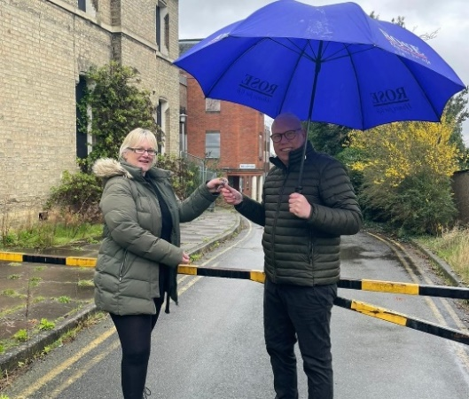 | We have completed the sale of our former Melton Hill offices in Woodbridge, to the family-run Manningtree building firm, Rose.  The site has been vacant for more than six years since the offices moved to Riduna Park in Melton.  Rose has a history of working in the town – most recently on the Queens Drive development of 33 new homes.
Read more at www.eastsuffolk.gov.uk/news/east-suffolk-council-completes-sale-of-former-melton-hill-offices-in-woodbridge/

Masterplan finalised for South Lowestoft and Kirkley
Following extensive public consultation, the Lowestoft Seafront and High Street Heritage Action Zone has been published.

Initiated by the Council through the London Road, Lowestoft High Street Heritage Action Zone (HSHAZ), the Masterplan has been developed to enhance public spaces and improve connectivity between the seafront, Kirkley Village and the town centre with the overall aim of enhancing the area for residents and visitors.

View the Masterplan at www.eastsuffolk.gov.uk/news/masterplan-finalised-for-south-lowestoft-and-kirkley/

Our wild spaces are back
Returning for its third year, our ‘Pardon the weeds, we’re feeding the bees’ campaign is back, with over 100 wild spaces where grass and wildflowers are left to grow to help wildlife thrive.
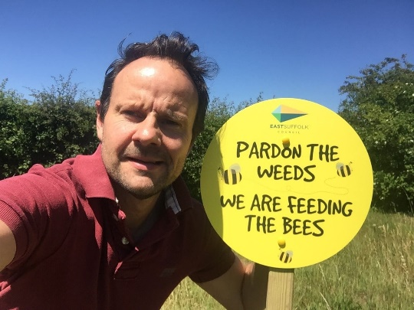 | These areas, which are large enough to provide an environmental benefit and do not present any safety issues for local communities, will be marked with our eye-catching yellow signs to make residents and visitors.  Town and parish councils, supported by Norse, will monitor the conservation areas to remove litter and control any invasive plant species.

This year, we’re also encouraging town and parish councils to create wild spaces on their own land – these will be marked with special green ‘Pardon the Weeds’ signs.

See a full list of all our wild spaces here: www.eastsuffolk.gov.uk/news/wild-spaces-return-to-east-suffolk/

New programme agreed to drive down number of empty long-term homes
An ambitious three-year programme has been agreed to drive down the number of long-term empty homes in East Suffolk.

Long-term empty properties are defined as residential properties that have been empty for at least two years.

In East Suffolk, 280 properties in private ownership have been empty for more than two years. These will be prioritised for action according to type, location, duration unoccupied, and housing need in the surrounding area.

The appointment of a dedicated Empty Homes Officer was among proposals put forward to drive policy.

New affordable homes welcome first residents
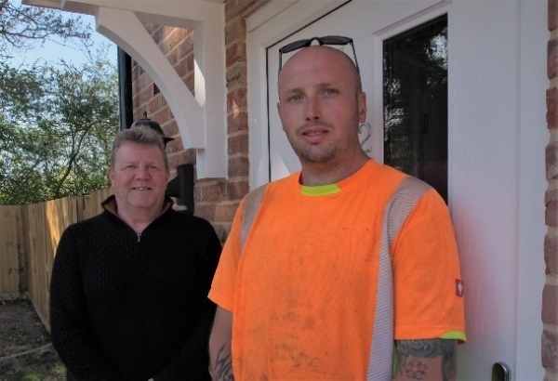 | A contractor who worked on a new housing development near Saxmundham has been able to move into one of the homes himself.  At the end of March, the Council completed the purchase of eight properties at Darsham Meadows, including four affordable rent homes to be added to our own Housing Revenue
Account (HRA) stock.

While two of the remaining four properties are still available under shared ownership via Orwell Housing Association, all of the affordable rent properties have been taken up by tenants, including a one-bedroom home occupied by Lee Jones.

The 33-year old fencer worked on the same development during its construction and moved just down the road from his family home in the village.

Read more about the development at www.eastsuffolk.gov.uk/news/new-and-affordable-homes-welcome-first-residents-in-east-suffolk-village/

Delivering sustainable homes in East Suffolk
A new planning document has been adopted in East Suffolk to help guide the development of sustainable buildings in the district.
The new Sustainable Construction Supplementary Planning Document provides planning guidance on a wide range of sustainable construction topics include energy efficiency, renewable energy, water management and conservation, construction methods, and use of materials.

View the plan at www.eastsuffolk.gov.uk/planning/planning-policy-and-local-plans/supplementary-planning-documents/

Grant funded training providing lifesaving first aid skills
A group of publicans and licensed premises staff from venues across Felixstowe have picked up some potentially lifesaving skills thanks to training funded by East Suffolk Community Safety Partnership (CSP).

Funding for up to 24 places on a first aid training course was provided by East Suffolk CSP for members of the Felixstowe Nightsafe network.
The Felixstowe Nightsafe network was formed in 2002 by local licensees, supported by Suffolk Constabulary and the CSP, with the aim of working together to prevent and reduce disorder around local licensed premises.

The dedication of local licensees has previously been commended for helping to make the town a safer place with a co-ordinated approach to identifying and preventing potential problems.

East Suffolk CSP was established to help improve the quality of life of people living in the district by promoting safe and healthy communities, with the co-operation of the police, district and county councils, probation, fire and rescue service, and public health.

New community play area is officially open
A new play area in Grundisburgh, created by the local community, has been officially opened.  Supported in part by community fundraising, historic Section 106 contributions and funding from the Kesgrave, Martlesham and villages Community Partnership, the creation of the new Grundisburgh Community Play Park has been a community effort, with involvement from across the village, including the Grundisburgh Playing Field Committee and the local Horticultural Society who helped with planting.  Funding was also provided by East Suffolk ward councillors, Cllrs Colin Hedgley and Tony Fryatt through | 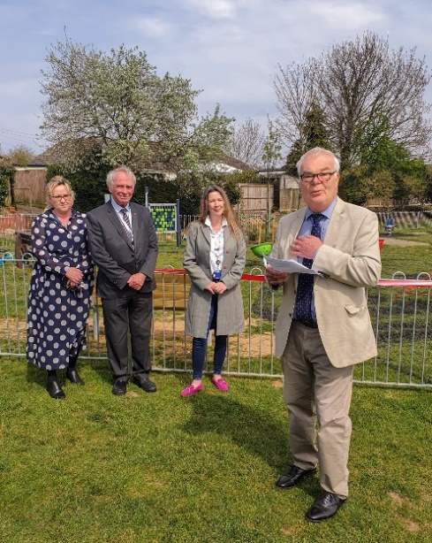
their Enabling Communities Budgets.
Designed and built by contractors Kompan, the play area has equipment suitable for children of all ages and also benefits from a community garden with new flower beds, trees and shrubbery to increase biodiversity and provide habitat for local pollinators.
Surveys and consultations
We are currently running a number of consultations and, as always, we want to encourage participation as feedback from people in East Suffolk is invaluable and helps us ensure we’re making the right decisions for our communities.

- Firework displays on council-owned land
As part of a review into firework displays on council-owned land, we have launched an 8-week consultation to better understand how residents feel about them and whether the rules need to be reconsidered. The consultation closes on Friday 20 May: www.eastsuffolk.gov.uk/features/new-consultation-seeks-views-on-firework-displays/

- Bungay Neighbourhood Plan
Local residents are invited to comment on the Bungay Neighbourhood Plan, ahead of it being submitted for independent examination. When finalised, the Neighbourhood Plan will be required to be used by anyone considering, or making, a planning application in the Bungay Neighbourhood Area. The consultation is open until Monday 6 June at www.eastsuffolk.gov.uk/planning/neighbourhood-planning/neighbourhood-plans-in-the-area/bungay-neighbourhood-area/

- Rushmere St Andrew Neighbourhood Plan
Local residents are invited to comment on the Rushmere St Andrew Neighbourhood Plan, ahead of it being submitted for independent examination. When finalised, the Neighbourhood Plan will be required to be used by anyone considering, or making, a planning application in the Bungay Neighbourhood Area. The consultation is open until Monday 6 June at www.eastsuffolk.gov.uk/planning/neighbourhood-planning/neighbourhood-plans-in-the-area/rushmere-st-andrew-neighbourhood-area/

Cllr Richardson indicated he had nothing additional to report.

Police Report

Suffolk Police Crime Data Latest data

Newbourne –2 crimes reported (Watermill Road) 1 x Theft from person 1 x violence and sexual offences
Waldringfield Heath – 1 crime reported (behind the Church) 1 x anti-social behaviour
Bucklesham – 1 crime reported (The Shannon) 1 x Other crimes
Hemley – 2 crimes reported (Church Lane) 2 x criminal damage and arson

3.To RECEIVE declarations of pecuniary interest – None received

4.To APPROVE the minutes of the Parish Council meeting held on 9th May 2022. Motion to approve minutes – all in favour

5. To CONSIDER Planning Applications for COMMENTS: None

6. MATTERS for REPORT from minutes of previous meetings and to REVIEW ACTION POINTS from the minutes of the Parish Council meetings held on 09/05/2022
- Parking on the verge opposite the Newbourne Fox. Planters have been put on the verge and The Fox has been granted planning to use their car park all year round. It has been reported that vehicles are now parking behind the planters.
Cllr Grainger is going to address the issue with the Newbourne Fox and see if a planter can be put on the end to stop the parking on the verge.

7. To DISCUSS play area. We are awaiting quote to come back for matting under the zipwire, Bucket swing etc this will be discussed in the next meeting 06/06/2022. The zip wire and part of the climbing wall and being repaired to make it safe and this should be complete in the next few weeks.

8. To DISCUSS the Queen Platinum Jubilee celebrations. Thank you to all the Cllr’s and their families that were involved in making our Jubilee celebrations happen giving up their free time to make the event happen.

A big thank you also goes to
- Tracey Holt who designed the posters and signs, decorations, organised the men and was brilliant on the day helping in all areas.
- Collin Pollard for making the signs
- Howard Cook and Tim Leeder getting involved and painting the play area.
- All the local businesses that donated raffle prizes.
- Pat Frost for selling the most amount of raffle tickets.

A report from the day as follows

REPORT TO PARISH COUNCIL ON NEWBOURNE PICNIC JUBILEE PARTY 3RD JUNE 2022

The event took place from 1.30pm to 5.00pm at the Village Hall and green on 3rd June. The weather was fantastic on the day and approximately 350/400 people attended the event. Attendees were locals to Newbourne and neighbouring villages, family and friends and holiday makers from the campsites.
At the February 2022 monthly PC meeting the idea of a Jubilee celebration was discussed and it was agreed that this would be, largely, a free event for the community. The PC would fund the event as long as this was a reasonable amount.
On April 13th a small sub-committee of PCllrs and helpers commenced planning the event. We had 50 days to organise everything. At the May 2022 PC Gary Grainger reported that the event was estimated to cost approximately £1,800 if we were to provide a free event for people. The final NET COST to the PC came in at £732.29. So the event was held for 60% less that originally forecast.

The £732.29 breaks down as follows (full costing at the back of report):
 | ££:PP
Parish Council cheques raised in May 2022 | 538.91
Cheque needed from PC for East Coast Adventures | 245.00
Cheque needed from PC for Tim Leeder for wood oil | 52.50
Less Cheque owed to PC by Gary Grainger | -104.12
 | 732.29

Given that we agreed that this would be a, largely free, event and the good number that attended the event has likely cost around £2.00 per head.
The true cost of the event if we had to pay for all of the volunteer time, goodwill and donations would have been around £25-30K.
The event consisted of:
- Bits N Pieces live band
- Kids competitions (including the make a crown competition)
- Archery provided by East Coast Adventures
- A vintage tractor, car, and stationery engine display
- Tug of war competition
- Raffle with prizes donated by local businesses and PC friends
- A picnic
- Pop up bar
- Wood fired Pizzas
- Barista Coffee bar
- Luxury Ice cream Van (250 ice creams were consumed on the day!)
- Pirates Bracelets
- And the whole area was decorated in Jubilee fashion with bunting, a life-sized model of Her Majesty for selfies
The Parish Council provided funding for the band, decoration and equipment needed for the day and the pop-up bar. Running the bar and the raffle enabled a lot of the PCs costs to be recouped.
The raffle did an amazing job collecting £678 in cash on the day. A big thank you to Pat Frost for a brilliant raffle and the money raised.
The bar itself didn’t make money. The total cost of stock and license was £831, and the takings were £606.50. We never set out to make money. Our prices were pitched low as this was to be a, largely, free event. We provided about £100 in free drinks to contributors and donators on the day and the residue stock was distributed to the day’s helpers as a thank you gesture.
Goodwill for the event was incredible with donations of posters, leaflets, raffle prizes, the vintages cars, tractors and stationery engines display, the tent that we needed for the band, crown cash prizes and more.
A special thank you to:
PCllr Andrew Garfath-Cox
Pat Frost
Sue and Colin Pollard
PCllr Micheal Hadley
Tracy Holt
Howard Cook
Tim Leeder
Laura Naunton Parish Council Clerk
For all their help, commitment, enthusiasm and brilliance in planning and providing for the whole event. And also, a special thank you to all of the additional helpers from their families and friends in the lead up and also on the day who helped to set up, run and close down the event. Without all of their help it would not have been possible.
There were commercial operations in attendance that were self-funded and attended to sell their products. This was all in keeping with the spirit of the day and everything was reasonably priced and flowed. All the operators said that had been kept busy so the mix of things that we had in place were well received.
Feedback from people who attended the event was good and they are looking forward to future events!
4th June 2022

Picnic Party Financials:
Statement of costs | ££:PP
Set up costs
Decorations and equipment | 486.41 | PAID
Play area wood oil | 52.50 | PAID
Bits n Pieces Band | 300.00 | PAID
Extra play area wood oil | 52.50
East Coast Adventures | 245.00
Bar, bar license, Kids sweet prizes | 882.38
Total cost of event before takings on the day | 2,018.79
Takings on the day
Raffle draw | 678.00
Bar takings
Contactless (net of transaction fee @ 1.6%) | 133.00
Cash | 475.50
 | 608.50
Total takings on the day | 1,286.50
Net cost of event to Parish Council | 732.29
Settlement
Cheques already raised by Parish Council (May 22 meeting) | 538.91
Cheque owed to East Coast Adventures | 245.00
Cheque owed to Tim Leeder for extra wood oil | 52.50
Less Cheque owed to Parish Council by Gary Grainger | -104.12
 | 732.29
Breakdown of the £104.12 owed by Gary to PC
Cash taken on the day for Raffle and Bar | 1,153.50
Contactless payments taken by Gary | 133
Set up costs for bar, license and kids sweet prizes paid by Gary | -882.38
Less cash paid to band on the day | -300
Gary owes Parish Council | 104.12
The Cllrs discussed maybe another event to fundraise money so will add for future agenda to be discussed.

9. To RECEIVE and APPROVE the Financial Reports
Cheques
Eastern Play £120.00 Cheque number 100461 To remove the broken wood on the climbing wall and take away the broken zip wire.
Clerks Wages £494.10 cheque number 100460 till end of May 2022
HMRC £123.40 Cheque number 100459
Tim Leeder £52.80 cheque number 100454 oil for painting play area
East Coast Adventures £245.00 cheque number 100457 Jubilee Celebrations

All cheques signed by Cllr Frost and Scott.
Newbourne Parish Council
2022 onwards

Starting Balance £13,621.14
£567.00 Lewis Culf Defib Box £13,054.14 07/04/2022 100452
£113.40 HMRC £12,940.74 07/04/2022 100448
£22.80 SALC £12,917.94 26/04/2022 100450
£6000.00 Precept East Suffolk £18,917.94 29/04/2022
£60.00 CAS £18,857.94 29/04/2022 100451
£52.50 Oil for playground £18,805.44 11/05/2022 100454
£40.00 Defib Batteries £18,765.44 12/05/2022 100455
£486.41 Jubilee decorations £18,279.03 17/05/2022 100456
£245.00 East Coast Adventures £18,034.03 06/06/2022 100457
£52.50 T Leeder oil for play area £17,981.53 06/06/2022 100458
£123.40 HMRC £17,858.13 06/06/2022 100459
£494.10 Wages till end of May £17,364.03 06/06/2022 100460
£120.00 Eastern Play Area £17,244.03 06/06/2022 100461

10. Action points for next meeting 06/06/2022

Speed Device

- Get on rota with Waldringfield Parish council to use shared SID.
- Look into price for our own SID and bracket prices.
- Community Speed Watch
- Reports of the findings for local SID’S do they cut down speeding in the village.
- Stickers for bins / extra signs in the village.

Play Area

- Chase up Zipwire and climbing wall repairs
- Get quote for matting under zipwire, Swing etc
- Prices for a baby swing for play area
- Any grants we could use for updating play area

11. To DISCUSS any clerk’s correspondence

- The clerk advised that there are travellers at the Martlesham park and ride, and they had also been moved on and they have been on the Millennium field in Kesgrave and various sites in Ipswich. It was discussed that we can not block of the playing field as it is used we will keep an eye on the situation and discuss further if need be.
- Fly Tipping The clerk had reported a case of fly tipping on the farmers field towards to Kembrook Kennels as the large amount of rubbish is blocking a footpath.

Meeting closed at 20:45

